1. Watch terraform-03 video.

Watched Video

2) Execute the script shown in video.

Using Envronment Variables:-

PS C:\Users\Efroz Khan\Music\New folder> Set-Item -Path env:TF_VAR_filename -Value 'wild.txt'

PS C:\Users\Efroz Khan\Music\New folder> Set-Item -Path env:TF_VAR_content -Value 'I hate dogs'

PS C:\Users\Efroz Khan\Music\New folder> Set-Item -Path env:TF_VAR_prefix -Value 'Miss'

PS C:\Users\Efroz Khan\Music\New folder> terraform apply

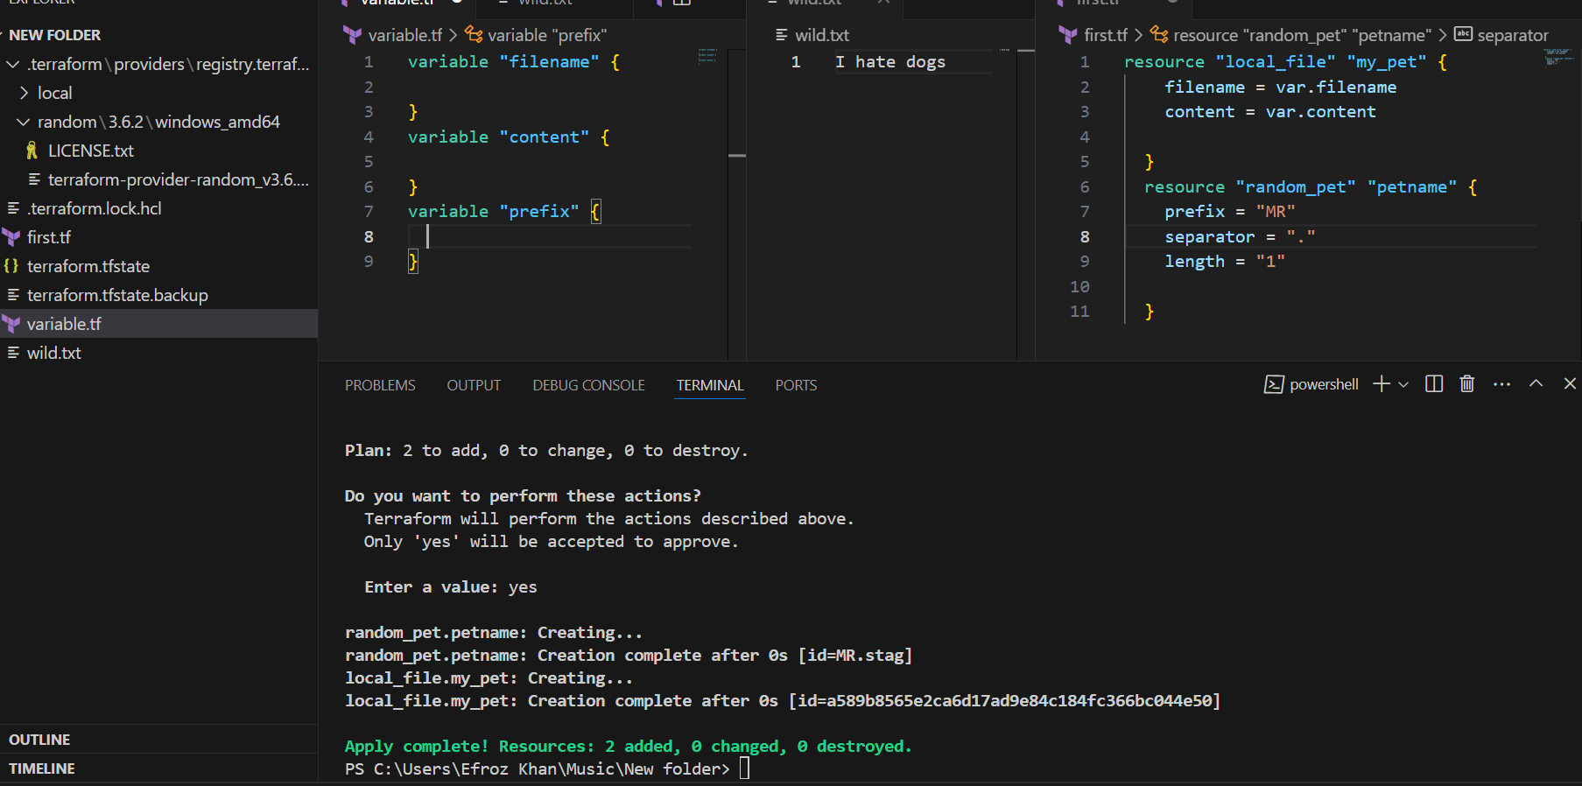

Passing Three Variables single time vartible.tf , environment variable and commandline flags env.But it takes only Command line flags variables remaing two variable are override.

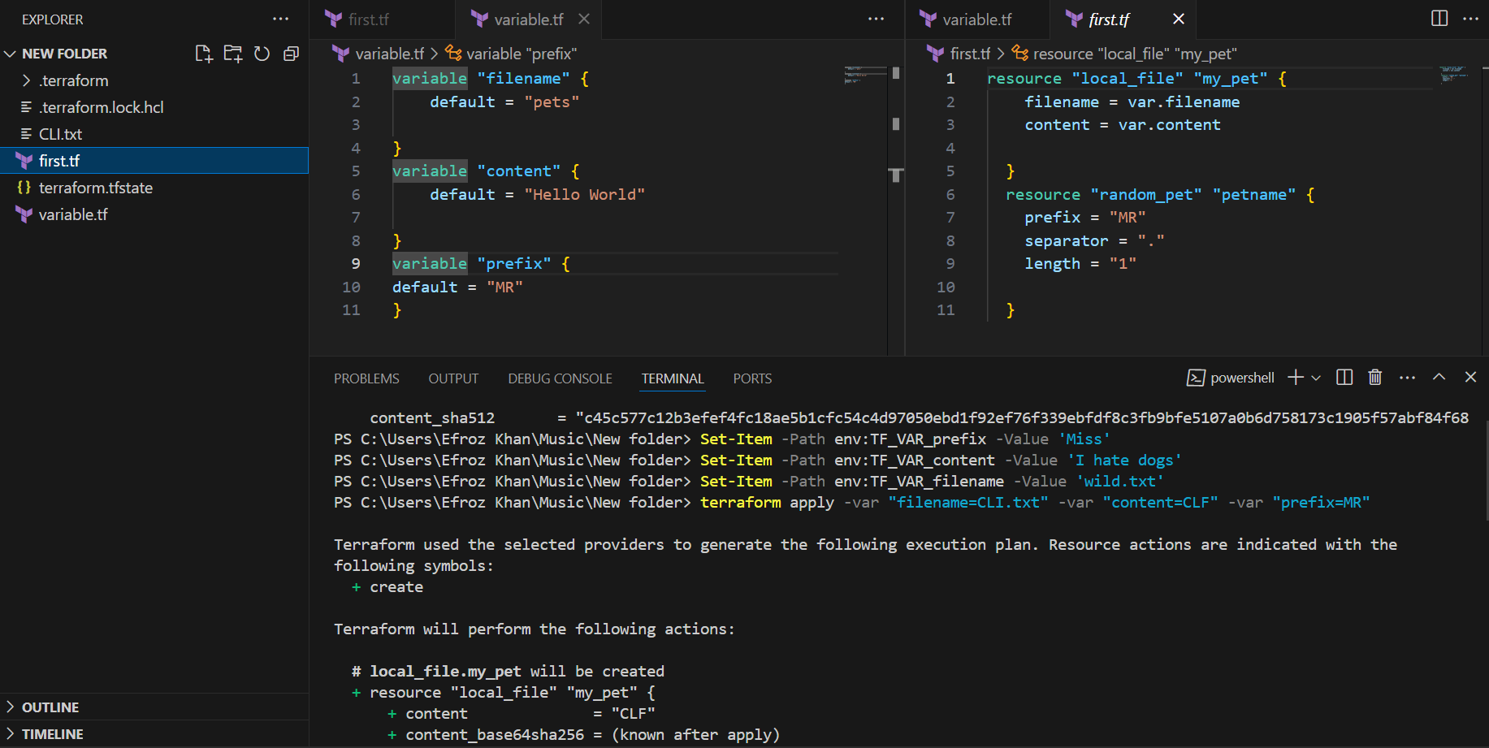

Resource Dependency picking random pet name in to the content

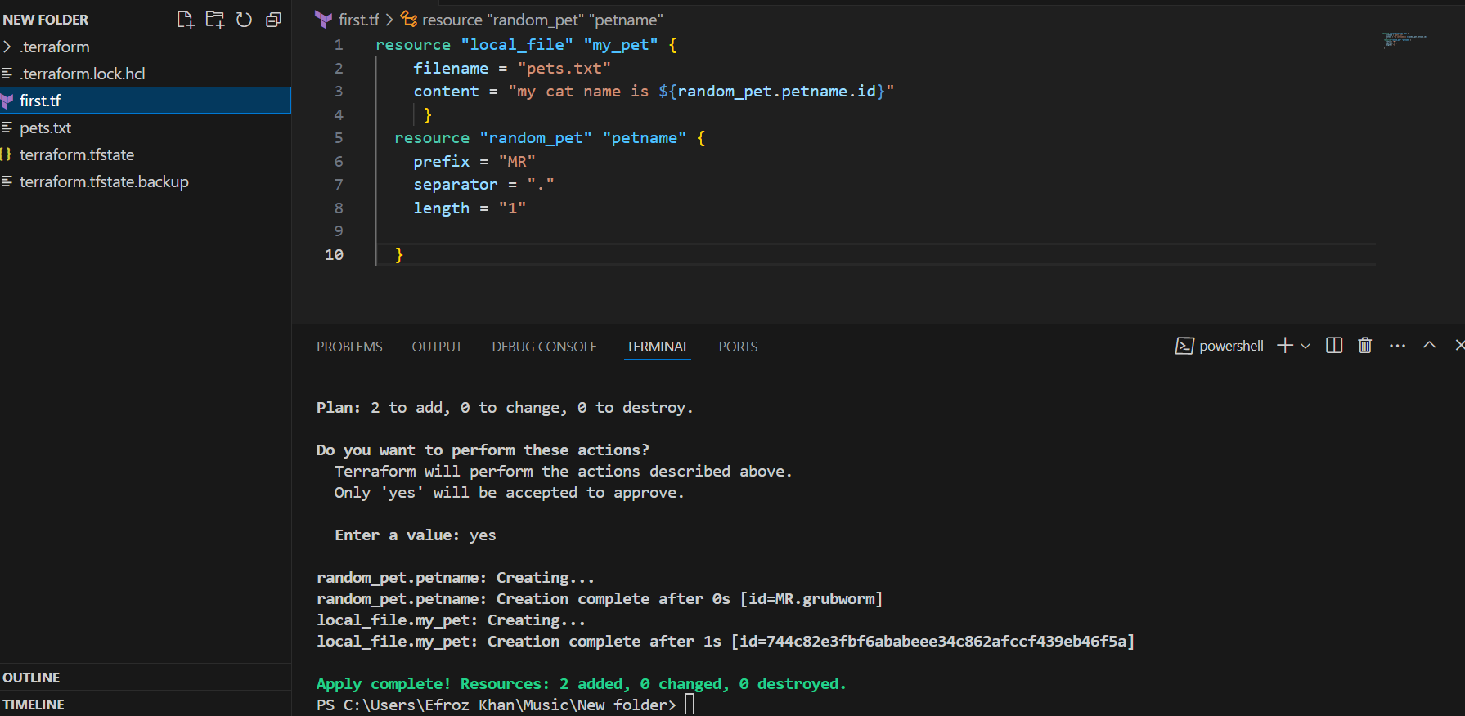

Output Variables:-

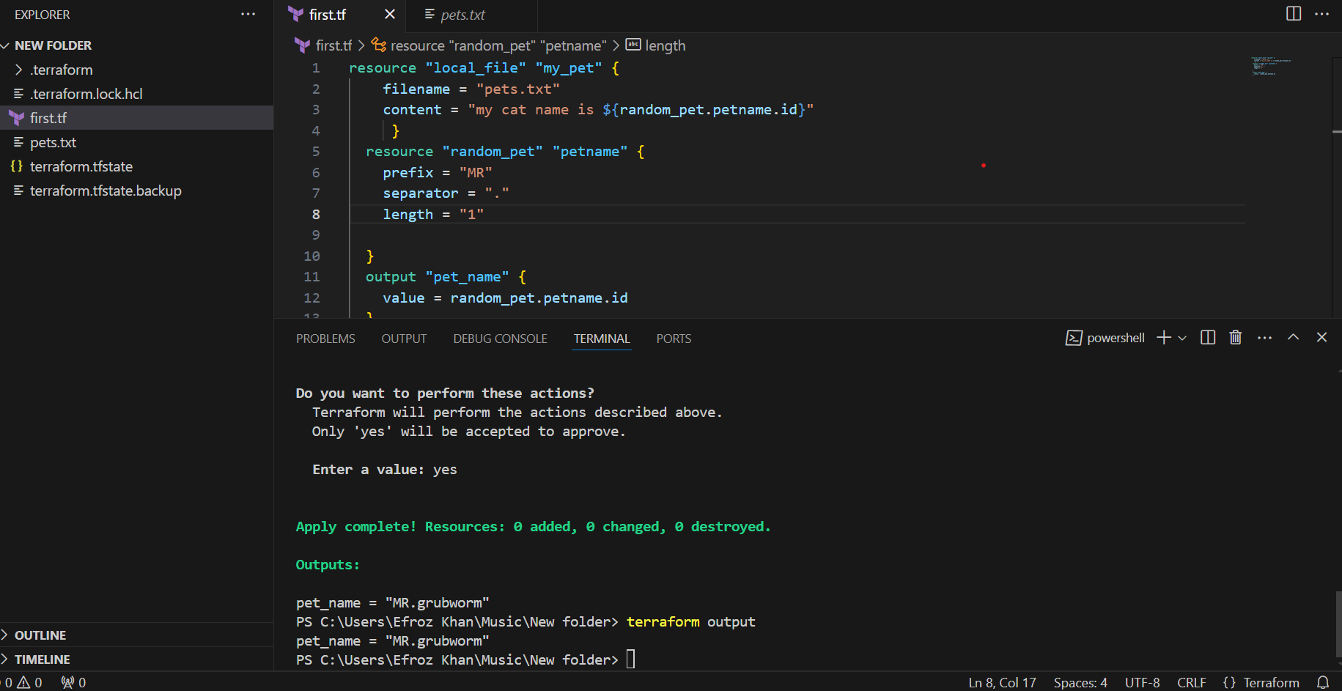

Terraform apply

Terraform output

Terraform show : terraform show command will show what ever store in the statefile.tf its show.

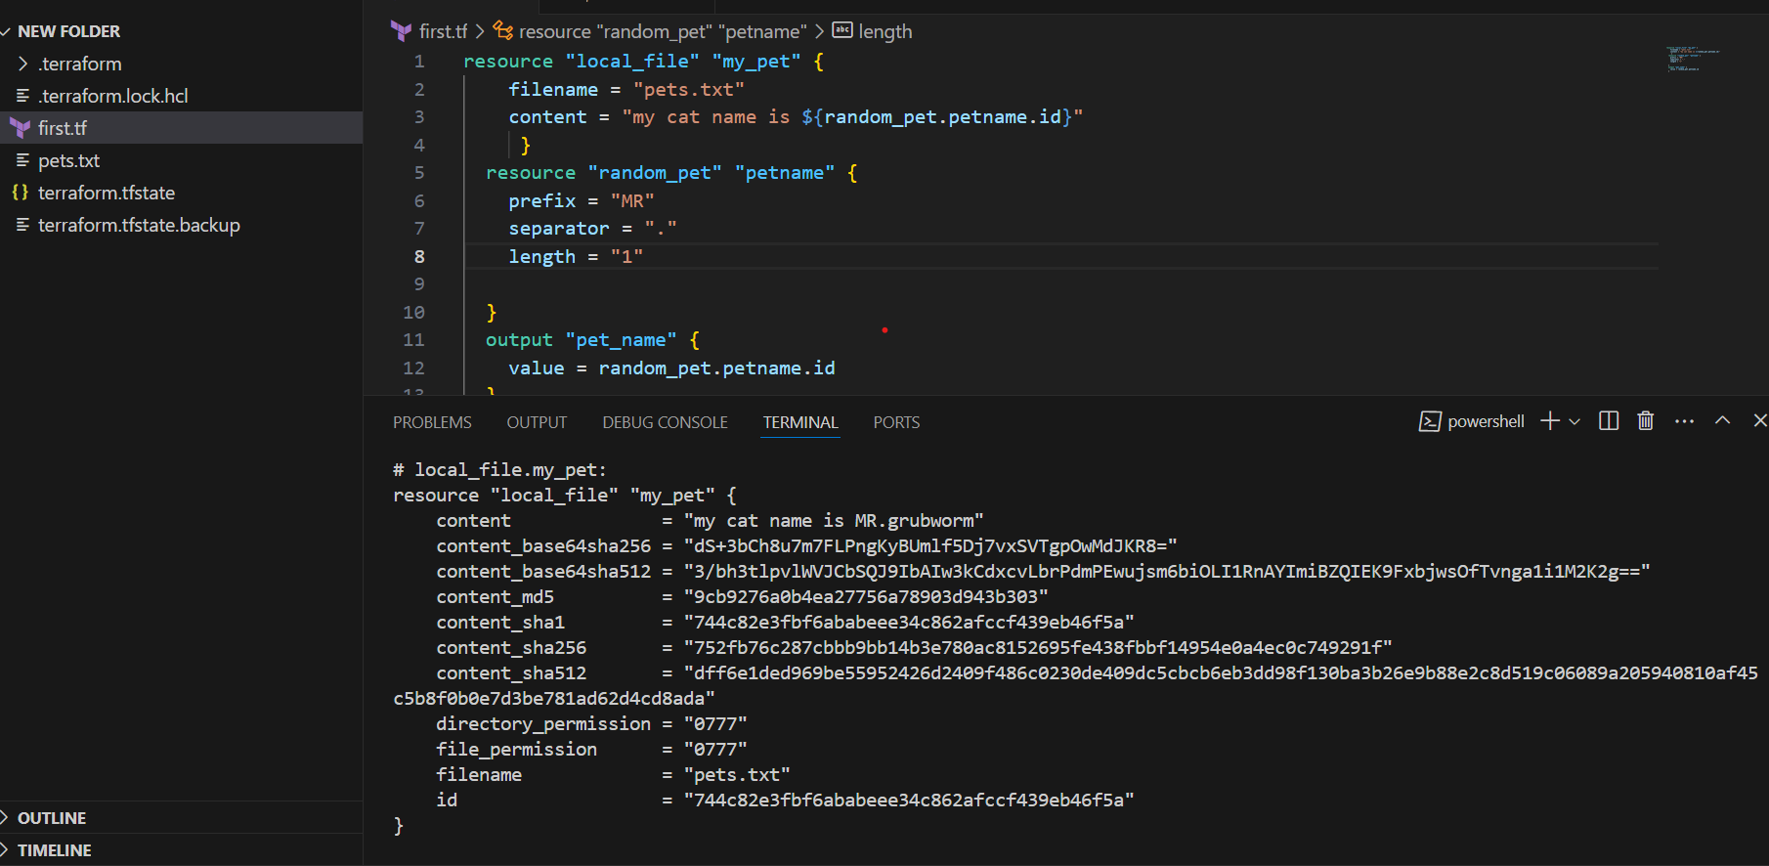

3) Intergrate terraform in jenkins using Terraform plugin.

4) Create one jenkins job using MAVEN PROJECT for the below code with two stages.

stage 1: Git clone

stage 2: Maven Compilation

Code: <https://github.com/betawins/java-Working-app.git>

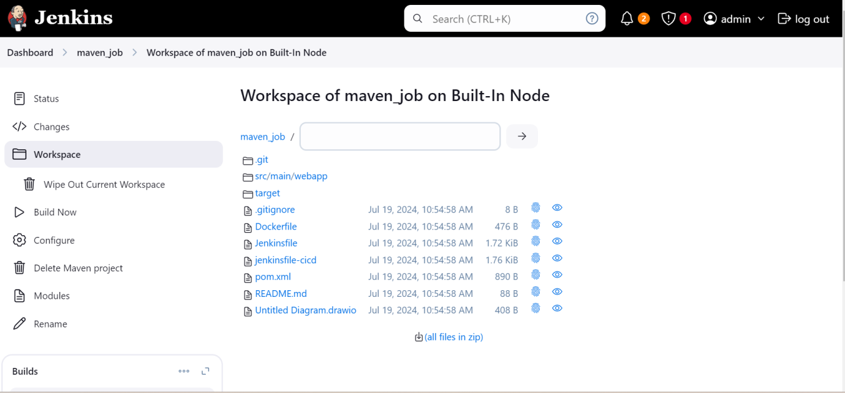

5) Use the below code and create a parameterized job in jenkins

stage 1: Git clone

stage 2: Maven Compilation

Code: <https://github.com/betawins/java-Working-app.git>

6) What are the global varaiables in jenkins?